RRFF Donation Application – MS 11/12/2023
This form is used by club members to sponsor and apply for a charity donation from RRFF funds to a deserving organization which will use it for activities that are consistent with our club objectives:
- To advance, promote, practice and teach the art of angling with artificial flies.
- To encourage the members and fisher persons everywhere to practice the high standards of sportsmanship long associated with fly fishing.
- To promote conservation and protection of wild game fish
The board requires that the sponsor be engaged with the organization/project they are seeking to fund. The board of directors will ask the sponsor to come before the board to discuss the application. The board will evaluate the proposal and decide based on merits and the club’s financial situation.
RRFF Sponsor | $ requested and when is donation required | Charity Name
Joe Hiney | $570, by June 2024 | Project Healing Waters Fly Fishing- San Francisco Program
Location/Region where money would be spent (local is preferred) | Purpose of Charity | Charity Navigator Score (if available)
San Francisco Bay Area | To help veterans with disabilities cope/rehabilitate in life through the healing power of fly fishing, and the camaraderie which develops at the casting pools, in the classrooms, and around the campfire. | 4 star (National organization, over 200 locations)
What specifically will donation be used for?
A PHWFF-San Francisco day outing in July, 2024, for 14 vets with disabilities and 7 volunteers to the Vadasz Vineyard in Sonoma, CA. The vets and volunteers will drive to Sonoma in the morning, fish Les and Judy Vadasz’s beautiful pond and likely landing many bass, before enjoying a picnic lunch. Mid-afternoon all will return home in the San Francisco Bay Area. The estimated cost of the outing, based on past such outings, will total $571, which consisted $340 for picnic supplies and $231 to reimburse those driving for gas.
The photographs below highlights the beauty of the Vadasz Vineyard pond and the ideal fishing access the pond provides for all the vets.

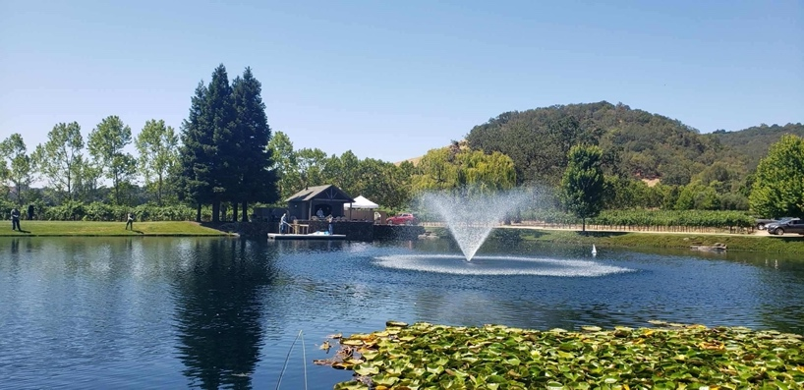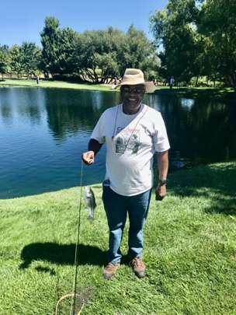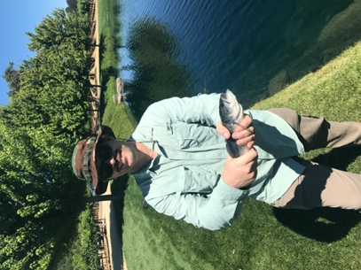
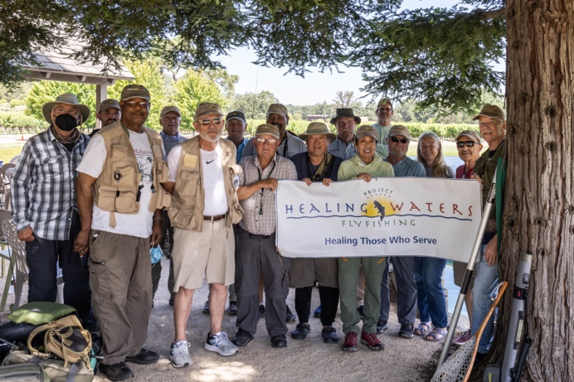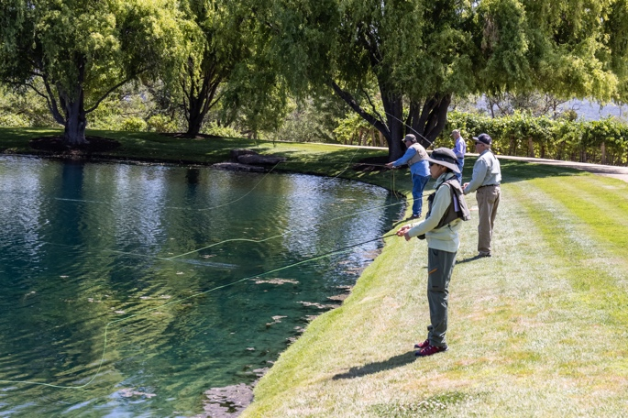
Photos from past PHWFF-SF outings to Vadasz Vineyards in Sonoma, CA

Describe your experience with the Charity, when this occurred and why you think a donation should be considered. (Add additional page if needed)
The RRFF has made prior donations for the last two years. $500, $550 – 2021, 2022

The article below has some additional info on PHWFF from Henry Little, SF program manager.
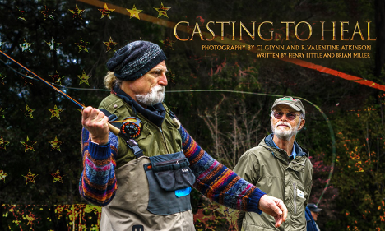
“Casting to Heal” features stunning photography by PHWFF volunteer CJ Glynn and GGACC member Val Atkinson. Written by PHWFF volunteers Henry Little and Brian Miller, it describes the healing qualities of casting for our disabled military veteran participants, enabled by a strong cadre of GGACC volunteers helping those who have served our country. Moreover, the issue recounts the Club’s pioneering history and our robust array of current fly fishing activities, the foundation upon which the PHWFF program succeeds.
You can see this special “Casting to Heal” issue by clicking here where you’ll enjoy a compelling foreword followed by a thumbnail which takes you to the full issue. Here you will also see a thumbnail for a previous Veterans Day edition, “Healing on the Fall” which captures a PHWFF outing to California’s Fall River in 2018.
Please note that these issues do not require subscriptions. GGACC and PHWFF would like to sincerely thank Todd & Kelley Moen for Catch Magazine’s continuing support of our disabled veterans!
Link: https://catchmagazine.net/?issue=veterans-day-2020
--
Henry Little
(415)264-7827 mobile/business
hplittle@gmail.com

RRFF Sponsor: Joe Hiney Date:
Prepared by Mike Spurlock based on input from Joe Hiney, and from Henry Little, Program Lead of PHWFF-San Francisco
Submit to Donation Coordinator who will let the sponsor know about next steps after review by the Board.

